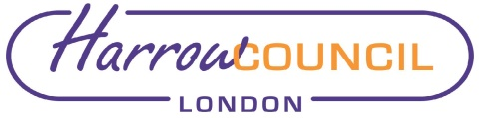
Report for: | Planning Committee
Date of Meeting: | 19 January 2022
Subject: | INFORMATION REPORT - Castle Public House – 30 West Street, Harrow on the Hill, HA2 3JA
Responsible Officer: | Beverley Kuchar – Interim Head of Planning
Exempt: | No
Wards affected: | Harrow on the Hill
Enclosures: | Appendix 1 – Guidance as to legislative framework for tree in conservation area related matters

Section 1 – Summary and Recommendations
This report sets out the current position with respect to Castle Public House, 30 West Street and provides an update to members as to the ongoing enforcement investigation.

Recommendations:
That the update is noted

Section 2 – Report
Background
The subject property is the Castle Public House, 30 West Street HA1 3EF. A planning application (ref: P/3890/21) was submitted in September 2021 for the installation of 2 x pergolas at the rear of the pub. The proposals indicated the pergola would be installed with all existing trees left in situ, in other words, none would be removed to facilitate the pergola.
This was granted permission 16/11/2021.
On 08 December, the Council received reports of trees being felled at the subject site.
The photo to the left shows the remaining stem of the multi-stemmed Cypress at the rear.
It should be clarified that a single, multi-stemmed tree was involved, and not three individual trees as was indicated in incoming emails. The photo shows the tree following removal of two of the three co-dominant stems.
On checking the recent planning application, and with confirmation from the relevant planning officer, it was noted that onsite trees were to be retained as part of the approved development. Namely, the Cypress, which was indicated as being retained, and a planning condition attached to the consent which stated

None of the existing trees on the site shall be lopped, topped, felled or uprooted without the prior written permission of the local planning authority
The tree is also protected by virtue of inclusion within the Conservation Area, which requires prior notice (6 weeks) to be given of any works to trees with stem diameter of 7.5cm or above. When notification is received (a s211 notice), the Council can either express no objection to the proposed works, or if the works are inappropriate and the tree is worthy of a Tree Preservation Order (TPO), the Council can serve a TPO. At the time of the incident no such notification had been submitted for the works.
This matter is being reported to the Planning Committee at the request of a nominated member.
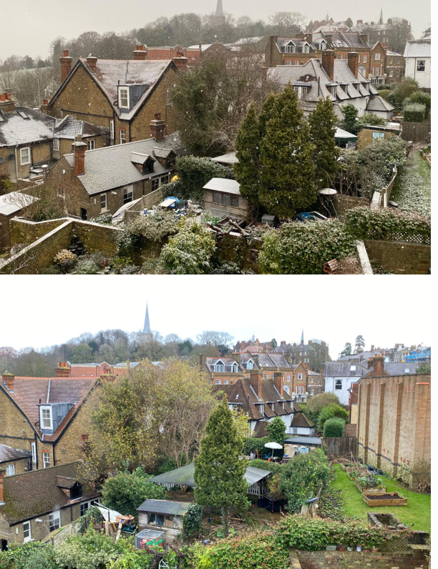
Subject tree/ impact of tree works
The subject tree is within the rear garden of the pub. The site slopes steeply upwards from front to rear. The subject tree is in an area at the rear of the garden and in a raised bed, so the tree is in an elevated and more prominent position. The three co-dominant stems give the appearance of three individual trees. The tree appeared to be in normal health and condition, although an inspection was not carried out prior to the works.
The tree provided good natural screening and was valued as a visual and sound buffer, by neighbouring residents. Its partial loss is therefore regrettable. In terms of its wider public visual amenity value however, the tree does not score highly. It cannot be seen from West Street so is not clearly visible from outside the site.
It should be noted that at present the Council is considering its options, and is investigating into alleged breaches of planning control. This paper is to update members as to the current position and is for information purposes only.

Legal Implications
None as this report is for information purpose only.
.

Financial Implications

None outside of normal departmental costs.

Risk Management Implications

Risks included on corporate or directorate risk register? No

Separate risk register in place? No

The relevant risks contained in the register are attached/summarised below. n/a

Equalities implications / Public Sector Equality Duty
Was an Equality Impact Assessment carried out? No

If no, state why an EqIA was not carried out below:

In exercising its functions the Council is required to have due regard to its equalities duties and in particular those set out in section 149 of the Equality Act 2010 to eliminate discrimination, harassment, victimisation and eliminate any other conduct that is prohibited by or under the Act and to advance equality of opportunity between persons who share a protected characteristic and persons who do not share it and to foster good relations between persons who share a relevant protected characteristic and persons who do not share it.

This update does not have any adverse impact on anyone with one or more protected characteristics, namely age, disability, gender reassignment, pregnancy and maternity, race, religion or belief, sex and sexual orientation.

Council Priorities
Please identify how the decision sought delivers these priorities.

- Improving the environment and addressing climate change

N/A

- Tackling poverty and inequality

N/A

- Building homes and infrastructure

N/A

- Addressing health and social care inequality

N/A

- Thriving economy

N/A

Section 3 - Statutory Officer Clearance
Chief Officer: Jimmy Walsh
Signed by the Head of Legal Services

Date: 18 January 2022

Mandatory Checks

Ward Councillors notified: YES

Section 4 - Contact Details and Background Papers
Contact: David Morren – Interim Head of Development Management 07926 073981
Background Papers: List only non-exempt documents (ie not Private and Confidential/Part II documents) relied on to a material extent in preparing the report (eg previous reports). Where possible also include a web link to the documents.
- Appendix 1 – Options for Trees in Conservation Area
- Planning Permission P/3890/21 - Civica Town - Search applications (harrow.gov.uk)
If appropriate, does the report include the following considerations?
1. Consultation NO
2. Priorities NO

